A000-Eur-Czech Republic-Dolní Věstonice-Figurine-Mammoth-29,000-22,000 BP

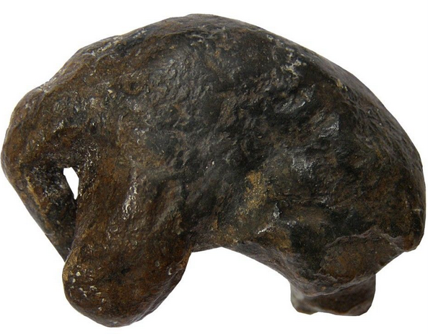

Fig. 1. Czech Republic-Dolní Věstonice-Figurine-Mammoth-29,000-22,000 BP

**Formal Label:** Czech Republic-Dolní Věstonice-Figurine-Mammoth-29,000-22,000 BP

**Display Description:** Dolní Věstonice, Moravia in the Czech Republic, is situated on the hill of Pollau, 549 m (1,801 ft) asl, and is dated to the Gravettian period (27,000-20,000 BP). This rendition of a mammoth is demonstrating the effects of its period in time, for it appears to be protecting itself from the cold, harsh climate.

**Accession Number: A000**

**LC Classification:** GN772.22.C95

**Date or Time Horizon:** 29,000-22,000 BP

**Geographical Area:** Moravia in the Czech Republic, on the hill of Pollau.

**Map, GPS 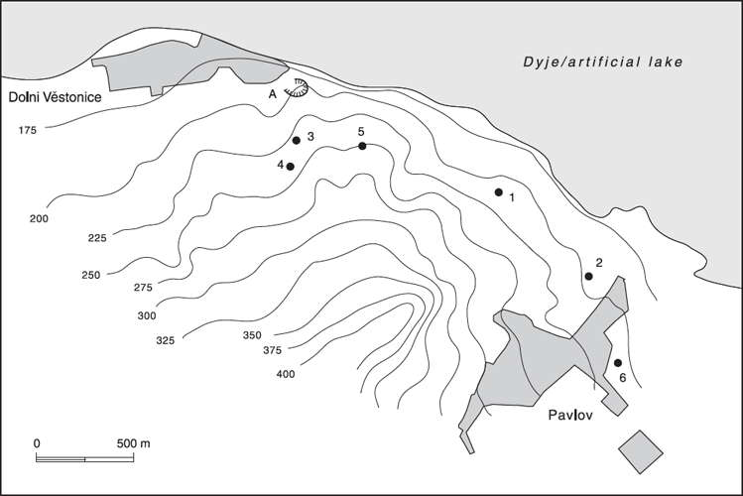Coordinates:** 48.88826 16.64364.

Fig. 2. Relief map showing Upper Paleolithic sites along the northeast side of the Pollau Hill. Dark line is the Dyje River. After Verpoorte (2000). Key: 1. Dolní Věstonice I; 2. Pavlov I; 3. Dolní Věstonice II; 4. Dolní Věstonice II-A; 5. Dolní Věstonice III; 6. Pavlov II.

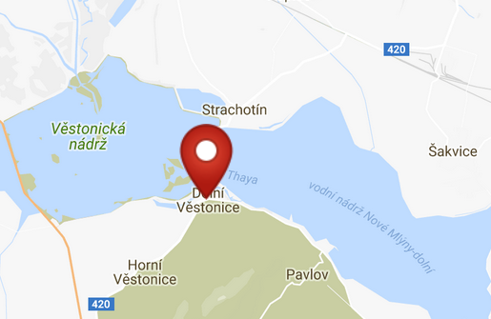 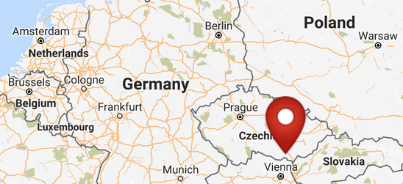

Fig. 3. Map of Dolni Vestonici. Fig. 4. Location of Dolni Vestonici in Europe.

Fig. 5. Map of Dolni Vestonici within Europe. After <http://latitude.to/img/latitude-logo.svg>

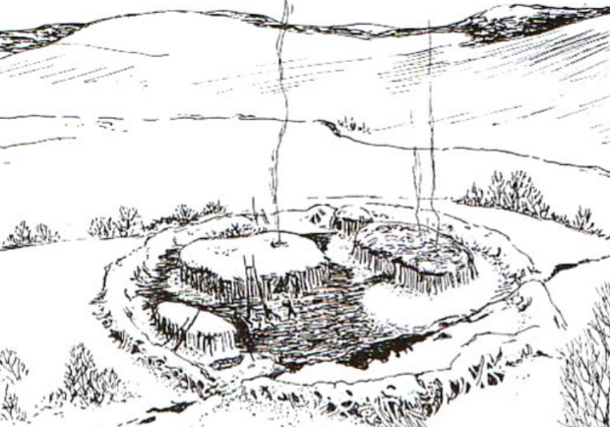

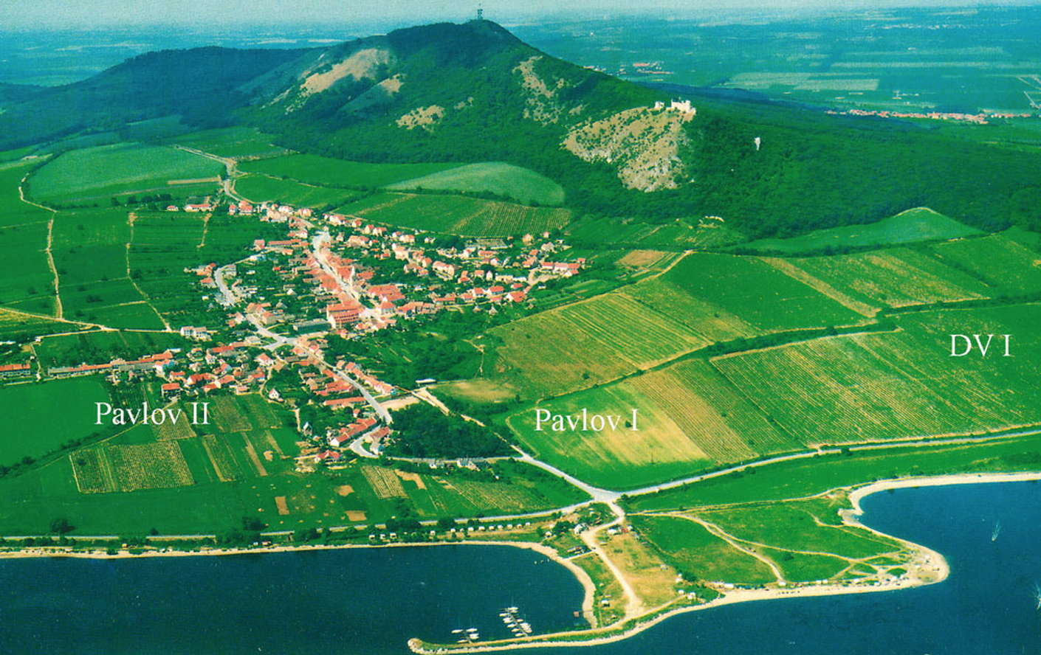

Fig. 6. View of Dolní Věstonice, Moravia, Czech Republic, 29,000 BP, after <http://humanpast.net/images/dolni.JPG>.

Fig. 7. Aerial view of Dolní Věstonice, Moravia, Czech Republic, 2004, after Svoboda (2007)

**Cultural Affiliation:** Gravettian period

**Medium:** ceramic

**Dimensions:** L 3.2 cm, H 2.3 cm, W 1.3 cm **Weight:**

**Provenance:** Anthroposmuseum in Brno, Czech Republic**, acc. No. 30020.**

**Condition:** museum replica in resin.

**Discussion:** The artist was intending to capture the essence of this hardship in a few well-chosen ceramic volumes: one for the main body, one for the front legs and one for the head and trunk.

**References:**

Trinkaus, Erik and Jiri Svoboda (Eds.) 2005.*Early Modern Human Evolution in Central Europe: The People of Dolní Vestonice and Pavlov* (Human Evolution Series). New York: Oxford University Press